Muscular strength, balance, and functionality in post-COVID-19 patients: An observational case-control protocol
Nádia O. Gomes^{1,2}, Jose Carlos da S. Junior^{2,3}, Felipe Augusto dos S. Mendes^{3,4}, Jean Carlos Coutinho¹, Vinicius Z. Maldaner^{1,2,3}, Isabella da S. Almeida^{1,5}, João Luiz Q. Durigan⁴, Graziella F. B. Cipriano^{2,3,4}, Gerson Cipriano Júnior^{1,2,3,4}.
Corresponding author: Nádia Oliveira Gomes
E-mail: ftnadiagomes@gmail.com
Received: 22 Sep, 2023.
Accepted: 15 Jan, 2024.
Published: 27 Mar, 2024.
Copyright © 2024. This is an Open Access article distributed under the terms of the Creative Commons Attribution Non-Commercial License which permits unrestricted non- commercial use, distribution, and reproduction in any medium provided article is properly cited.
¹ Human Movement and Rehabilitation Post Graduate Program, Evangelical University of Goiás –UniEVANGÉLICA, Anápolis (GO), Brazil.
² Research Group on Cardiopulmonary Rehabilitation (GPRC), University of Brasilia (UnB), Brasilia (DF), Brazil.
³ Physical Therapy Course, University of Brasilia (UnB), Brasilia (DF), Brazil.
⁴ Graduate Program in Health Sciences and Technologies, University of Brasilia (UnB), Brasilia (DF), Brazil.
⁵ Postgraduate program in Physical Education, University of Brasilia (UnB), Brasilia, DF, Brazil
Abstract:
Background: Persistent and systemic impairments have been reported in individuals recovering from COVID-19, including balance and muscle strength dysfunctions. However, the implications for static and dynamic Balance and their potential associations with muscle strength and functional assessments in patients with severe disease during the acute phase remain poorly understood in the existing scientific literature. Objectives: This study evaluates static and dynamic balance, lower limb muscle strength, and physical capacity in post COVID volunteers who experienced severe and critical forms of the disease. Additionally, it seeks to identify potential correlations between functional outcomes and demographic characteristics. Methods: This observational case-control study will enroll individuals who had experienced severe and critical forms of COVID-19 during the acute phase of the illness. Static Balance will be assessed using a Portable Baropodometry and Stabilometry platform, while dynamic Balance will be evaluated through the MiniBest Test. Muscle strength will be measured by Isometric Quadriceps Muscle Strength during contraction of knee extension, flexion, and physical capacity utilizing the 1-minute Sit-to-Stand Test (1MST). Hypothesis: We hypothesize that Long COVID volunteers who endured severe and critical forms of the disease during the acute phase will exhibit: 1)Impaired static and dynamic Balance compared to a control group of individuals without a history of COVID-19, as evidenced by significantly different scores on Baropodometry and Stabilometry assessments, as well as the MiniBest Test. 2)Reduced lower limb muscle strength compared to the control group. 3) Decreased physical capacity as assessed by the 1-minute Sit-to-Stand Test (1MST) when compared to individuals without a history of COVID-19. 4) Possible associations between demographic characteristics (age, gender, and physical activity level) and the observed functional outcomes. We anticipate that these findings will contribute to a better understanding of the long-term effects of severe and critical COVID-19 on Balance, muscle strength, and physical capacity.
Keywords: Long Covid; Balance; functional capacity; muscle strength.

BACKGROUND

In 2020, the Chinese Center for Disease Control and Prevention published preliminary data on 44.672 patients infected with SARS-CoV-2⁽¹⁾, marking the onset of the COVID-19 pandemic period that lasted approximately three years. SARS-CoV-2 infection was able to produce a range of clinical manifestations classified into five severity levels from asymptomatic to critical, according to various signs presence, including 1) common COVID-19 symptoms, 2) shortness of breath or dyspnea, 3) abnormal chest imaging, 4) low oxygen saturation and 5) oxygen supplementation or ventilation support⁽²⁾.

However, SARS-CoV-2 displayed a multi-systemic impact and the potential for late-onset symptoms, encompassing a wide array of ailments such as fatigue, shortness of breath, cough, chest pain, palpitations, fever, headache, muscle aches, muscle weakness, dizziness, gastrointestinal issues, and loss of taste and smell. This context gave rise to an alternative diagnosis known as Long COVID, characterized by symptoms persisting for up to three months, with a minimum duration of two months. Long COVID is a multifactorial condition, not limited to its physical repercussions but also extends to encompass biopsychological aspects and social and financial implications, primarily attributable to its functional impact^{(3,4)}.

In Long COVD patients, several functional limitations have been documented, encompassing a decline in global cardiorespiratory capacity⁽⁵⁾, cardiovascular function⁽⁶⁾, and respiratory performance⁽⁷⁾. Additionally, emerging research has highlighted alterations in skeletal muscle quality and structure in these individuals, potentially influencing muscle strength, endurance, and associated functions, such as body movement⁽⁸⁾ and stabilization⁽⁹⁾. Notably, this population also faces various neurological impairments, including dizziness and posture stability, which can further impact postural Balance in Long COVD patients⁽¹⁰⁾.

Previous investigations in this field have predominantly employed less precise methodologies, encompassing functional balance assessments⁽¹¹⁾, dynamic posturography⁽¹⁰⁾, and questionnaire-based evaluations⁽¹²⁾. These studies have predominantly focused on individuals with mild to moderate symptom severity, often conducted during the acute phase, typically from 15 days to 12 weeks post-infection^{(13,14)}. Moreover, these studies have seldom included comparative analyses with control groups to comprehensively understand the observed effects. Furthermore, comparative analyses with control groups have been infrequently incorporated in existing studies, limiting a comprehensive understanding of the observed effects. Given the scarcity of research on this topic, our study aims to offer novel insights into the balance issues experienced by Long COVID patients. By utilizing more suitable assessment tools and exploring potential associated factors, our research seeks to enhance comprehension of the challenges faced by this population, ultimately contributing valuable knowledge for the development of rehabilitation protocols.

Objective

To assess muscular strength and Balance in patients with Long COVID and its impacts on functional capacity.

Secondary objective

To investigate the relationship between functional capacity and the severity of COVID-19. To contribute valuable information and data to the fields of Science and Physiotherapy regarding assessing and treating patients with Long COVID.

Trial Design

This is an observational case-control study.

METHODS: PARTICIPANTS AND OUTCOMES

Study setting

This study will be conducted at the Ceilândia Campus of the University of Brasília in the Clinical Exercise Physiology Laboratory (LabFCE) on prespecified dates and times. This protocol adheres to the SPIRIT guidelines, and a study flowchart is described in Figure 1.

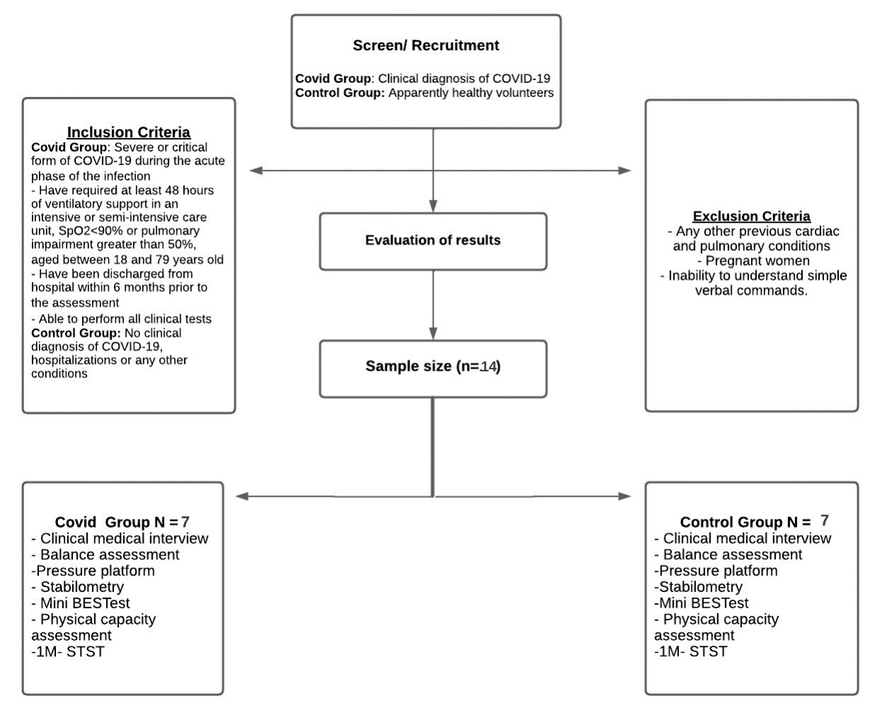

Figure 1. Protocol flowchart

Elegibility Criteria

Inclusion criteria

The sample will consist of two groups: 1) Individuals diagnosed with clinical COVID-19 and 2) Healthy volunteers matched for gender, age, and body mass index (BMI). For the COVID-19 group (CASE group), volunteers who experienced severe or critical COVID-19 during the acute phase of the infection will be included. This includes individuals who required at least 48 hours of ventilatory support in an Intensive Care Unit or semi-intensive care unit, had SpO2<90%, or exhibited lung involvement exceeding 50%. Eligible participants will be aged 18 to 79, discharged from the hospital within six months before the assessment, and capable of performing all clinical tests. The CONTROL group will consist of individuals prospectively recruited, matched for age, height, weight, and gender, who have not received a clinical diagnosis of COVID-19, hospitalizations, or any suggestive symptoms of COVID-19 infection.

Exclusion criteria

Patients with pre-existing medical conditions, pregnant individuals, and those unable to understand simple verbal commands will be excluded. Informed consent will be obtained from all participants in accordance with Brazilian federal laws.

Criteria for discontinuing

Patients with clinical decompensation during proposed assessments.

Strategies to improve adherence.

We planned to conduct assessments quickly, minimizing the intervals between them.

Outcomes

In conjunction with collecting initial clinical and demographic data to characterize the study population, we will assess primary and secondary outcomes following the specifications delineated in the study protocol, which are elaborated upon below.

Participant Timeline

The assessments will have an approximate duration of 60 to 90 minutes.

Sample Size

Considering an effect size of 0.67 from a previous publication⁽¹⁵⁾, an α error probability of 0.05, and a power (1- β error probability) of 0.80 for repeated measures, a total sample size of 14 individuals (7 per group) is necessary to reach a power of 21%. G*Power Statistical Power Analyses for Mac was utilized, according to the appropriate reference:

Recruitment

The groups will consist of individuals prospectively recruited and matched for age, height, weight, and gender in both case and control groups. Recruitment will initially be through social media, publicity in some hospitals and snowball sampling.

METHODS: DATA COLLECTION, MANAGEMENT, AND ANALYSES

Data collection methods

Study Procedures

Participants, selected according to the sample criteria, will comprehensively assess their static and dynamic balance, lower limb strength, and physical capacity. After an initial clinical assessment, Balance assessments employ the Mini-Balance Evaluation Systems Test (Mini-BESTest), Baropodometry, and Stabilometry platform. Lower limb strength will be assessed through Isometric Quadriceps Muscle Strength dynamometer and Functional capacity using the 1-Minute Sit-to-Stand Test, as illustrated in Flowchart 1.

Initial Clinical Assessment

Participants will be evaluated using a standardized form regarding the disease history and severity. Subsequently, initial vital signs will be assessed, including oxygen saturation (SpO2, %), pulse rate (PR, bpm) using an Oximeter, and systolic and diastolic blood pressure (SBP and DBP, mmHg) using a digital sphygmomanometer. The Borg Rating of Perceived Exertion scale (6 to 20) will be presented for later assessment during exertion, as well as the Medical Research Council (MRC)scale to assess dyspnea before and after functional tests.

One-Minute Sit-to-Stand Test (1-MSTST)

The One-Minute Sit-to-Stand Test (1-MSTST) will be performed using a standardized chair (height 38-42 cm) with a flat seat and no arms, stabilized against a wall. Patients will be asked to sit with their legs hip-width apart and flexed at 90°, with their hands relaxed on their hips without using their hands or arms to assist the movement. Patients will be encouraged to perform as many repetitions as possible within 1 minute. Rest will be given after the test to avoid excessive fatigue. At the start of the test, the patient must have their back against the chair's backrest, and at the end, they should return to that position. The variable obtained through the test will be the repetition number.

Isometric Quadriceps Muscle Strength

Quadriceps muscle strength will be assessed using an isometric dynamometer while performing a knee extension movement on an adapted chair (Isometric dynamometer, Cefise, Nova Odessa/SP, Brazil). Volunteers will be instructed to make three attempts at dominant knee extension at a 60-degree angle. Peak torque will serve as the parameter for measuring strength, representing the maximum torque point within the range of motion, and will be measured in Newton meters (Nm).

Mini-BEST Test

The Mini-BESTest consists of a feasible measure for clinical practice with 14 items focusing on the evaluation of dynamic Balance with an expected duration of 10 to 15 minutes. The test includes the following domains: anticipatory postural adjustments (up to 6 points), postural responses (up to 6 points), sensory orientation (up to 6 points), and gait stability (up to 10 points). The score for each domain ranges from 0 to 2. The sum of all domains can vary from 0 to 28, with higher scores indicating better postural Balance.

Portable Baropodometry

The Balance will be assessed using the Sports Balance Analyzer™, a portable baropodometry equipment (TEKSCAN, Massachusetts, USA). Participants will stand on the platform with bare feet, aligned with the platform, positioned 20 cm apart without additional support. While on the platform, the participant will be asked to perform a simple task, such as closing their eyes for a few seconds and then opening them while looking at a fixed point on the wall until the assessment is completed. Subsequently, a cognitive task, such as a simple calculation (e.g., 70-7), will be added to the postural control task with your eyes open and closed, creating a dual-task scenario under the equipment. Dual-task testing simulates daily life tasks. During each of these assessment moments, pressure oscillations and weight distribution will be captured by the device.

Stabilometry plattaform

Balance will be assessed through quantitative recording of posture maintenance using a stabilometry platform (Balance System SD, BIODEX, New York, USA). This equipment consists of a circular platform that can move in the anterior, posterior, medial, and lateral directions, with the capacity to produce clinical data measurements related to Balance applicable to various populations. Previous studies have demonstrated its reliability for objectively assessing postural stability.

The Stabilometry platform has its evaluation protocols that will be used in the assessments. The first protocol we will use is "Postural Stability," which aims to assess the individual's postural instability. The second protocol is the "Fall Risk," which evaluates the risk of falling in individuals. In both protocols, the positioning of the feet is essential so that the participant feels comfortable throughout the assessment. Participants should not remove their feet from the initial marking because it will be recorded at the beginning and must remain the same until the end. The assessments typically last 3 minutes. The first minute is dedicated to recording the participant's name, height, weight, and foot positioning. The remaining time is allocated for the test, which consists of approximately 3 stages of 20 seconds each, with 10-second intervals between the stages. In the "Postural Stability" protocol, participants are instructed to maintain an upright posture on the unstable platform, avoiding balance oscillations without placing their hands on the device's support bars.

On the other hand, in the "Fall Risk" protocol, participants are asked to maintain an upright posture on the platform, which will constantly change its level of instability during the test, shifting from the most unstable to the least unstable, without using the handrails for support. Both protocols will be conducted twice, once with participants' eyes closed and once with their eyes open. The variables obtained through stabilometry will include the Overall Stability Index, Anterior/Posterior Index, and Medial/Lateral Index.

Data management

In order to validate the individuality of the information, volunteers will be identified solely through codes in the computerized databases, ensuring the privacy and confidentiality of the participant's identification.

Statistical Methods

For statistical analysis, we will use SPSS 24.0 software (IBM Corp., Armonk, NY, USA). Data will be presented following the STROBE guidelines for observational studies , in various formats depending on the distribution's nature, including absolute and relative frequency, mean ± standard deviation, mean (95% confidence interval, CI 95%), or median (interquartile range 25-75%). Group comparisons will be conducted using paired or unpaired Student's t-test, Mann-Whitney, or Wilcoxon test. Comparisons among more than two paired groups will be performed using repeated measures ANOVA. Correlations will be tested using Pearson or Spearman correlation coefficients. A p-value ≤ 0.05 will be considered statistically significant.

METHODS: MONITORING

Data monitoring

All gathered data will be securely recorded on a password-protected virtual platform. Subsequently, an experienced professional will conduct random analyses to ensure data quality and appropriateness.

Harms

This research involves minimal risks, as it uses well-established assessments in chronic disease research and clinical practice, with no reported significant adverse events⁠. Some participants might experience discomfort during questionnaires or evaluations, but we have taken precautions. Assessments will occur in private settings, with trained evaluators to make participants more comfortable.

Evaluators will be trained to prevent discomfort. While some fatigue may occur during physical tests, they will be tailored to each person's capabilities, allowing rest if needed. Participants can stop tests if uncomfortable and will have rest intervals. In the rehabilitation gym and physiology lab, thorough pre- and post-use cleaning and ventilation measures will prevent contamination.

Auditing

All gathered data will be audited monthly on a virtual platform with password protection to ensure data quality and appropriateness.

ETHICS AND DISSEMINATION

Research Ethics Approval

The project has received approval from the Research Ethics Committee (CAAE 36641820.8.0000.8153). All participants will provide written informed consent through the Informed Consent Form reading, discussing, initialing, and signing before any protocol procedures. Participants will be informed of their right to withdraw consent at any time without impacting their treatment.

Protocol Amendments

The project was registered on the clinical trials platform under Number Identifier NCT04595097. The variables assessed in this protocol were included in a 2nd amendment.

Consent for Publication and Confidentiality

Participants have given consent for publication and for their data to be stored in the laboratory database during and after the trial. Only researchers will access the data to ensure anonymity and respect for human dignity, in compliance with all bioethical requirements of National Health Council Resolution 466/2012 and the Helsinki Declaration for research involving human subjects.

Author Contributions: NOG - Acquisition, analysis, or interpretation of data for the work. JCSJ - Acquisition, analysis, or interpretation of data for the work. FASM - Substantial contributions to the conception or design of the work and final approval of the version to be published. JCC - Agreement to be accountable for all aspects of the work in ensuring that questions related to the accuracy or integrity of any part of the work are appropriately investigated and resolved. VZM - Drafting the work or reviewing it critically for important intellectual contente. ISA - Agreement to be accountable for all aspects of the work in ensuring that questions related to the accuracy or integrity of any part of the work are appropriately investigated and resolved. JLQD - Drafting the work or reviewing it critically for important intellectual contente. GFBC - Analysis, or interpretation of data for the work. GCJ – Substantial contributions to the conception or design of the work and final approval of the version to be published

Financial Support: Financial support for this work was partially provided by public research grants and scholarships from Brazilian fostering agencies: Coordenação de Aperfeiçoamento de Pessoal de Nível Superior (CAPES [Coordination for the Advancement of Higher Education Personnel]), Conselho Nacional de Desenvolvimento Científico e Tecnológico (CNPq [National Council of Scientific and Technological Development]) grant number 141130/2023-7, and Fundação de Apoio à Pesquisa do Distrito Federal (FAPDF [Federal District Research Foundation]).

Conflict of interest: There authors declare no conflicts of interest.

Data Availability Statement: All relevant data from this study will be available upon request.

REFERENCES
- Guan WJ, Ni ZY, Hu Y, Liang WH, Ou CQ, He JX, et al. China Medical Treatment Expert Group for Covid-19. Clinical Characteristics of Coronavirus Disease 2019 in China. N Engl J Med. 2020;382(18):1708-1720.
- WHO. World Health Organization‎. Coronavirus disease 2019 (‎COVID-19)‎: situation report, 46. 2020.
- Nabavi N. Long covid: How to define it and how to manage it. BMJ. 2020;370.
- Greenhalgh T, Knight M, A’Court C, Buxton M, Husain L. Management of post-acute covid-19 in primary care. BMJ. 2020;370(3026):m3026.
- Milani M, Milani JGPO, Cipriano GFB, Cahalin LP, Stein R, Cipriano Jr. G. Teste Cardiopulmonar em Pacientes Pós-COVID-19: De Onde vem a Intolerância ao Exercício? Arquivos Brasileiros de Cardiologia. 2023;120:e20220150.
- Chatzis DG, Magounaki K, Pantazopoulos I, Bhaskar SMM. COVID-19 and the cardiovascular system-current knowledge and future perspectives. World Journal of Clinical Cases. 2022;10(27):9602–10.
- Mancini DM, Brunjes DL, Lala A, Trivieri MG, Contreras JP, Natelson BH. Use of Cardiopulmonary Stress Testing for Patients With Unexplained Dyspnea Post–Coronavirus Disease. JACC: Heart Failure. 2021;9(12):927–37.
- Vaes AW, Machado FVC, Meys R, Delbressine JM, Goertz YMJ, Van Herck M, et al. Care Dependency in Non-Hospitalized Patients with COVID-19. Journal of Clinical Medicine. 2020;9(9):2946.
- de Sousa KCA, Gardel DG, Lopes AJ. Postural balance and its association with functionality and quality of life in non‐hospitalized patients with post‐acute COVID‐19 syndrome. Physiotherapy Research International. 2022;27(4).
- Yılmaz O, Mutlu BÖ, Yaman H, Bayazıt D, Demirhan H, Bayazıt YA. Assessment of balance after recovery from Covid-19 disease. Auris Nasus Larynx. 2022; 49(2):291-298
- Malayala SV, Raza A. A Case of COVID-19-Induced Vestibular Neuritis. Cureus. 2020; 12(6):e8918.
- De Sousa KCA, Gardel DG, Lopes AJ. Postural Balance and its association with functionality and quality of life in non-hospitalized patients with post-acute COVID-19 syndrome. Physiother Res Int. 2022 ;27(4):e1967
- Jaszczur-Nowicki J, Niźnikowski T, Makaruk H, Mastalerz A, Porter J, Biegajło M, et al. Effect of Coronavirus 19 on Maintaining Balance in Skilled Athletes. International Journal of Environmental Research and Public Health. 2022;19(17):10470.
- Giardini M, Arcolin I, Guglielmetti S, Godi M, Capelli A, Corna S. Balance performance in patients with post-acute COVID-19 compared to patients with an acute exacerbation of chronic obstructive pulmonary disease and healthy subjects. International Journal of Rehabilitation Research. 2021;45(1):47–52.
- Faul F, Erdfelder E, Buchner A, Lang AG. Statistical power analyses using G*Power 3.1: Tests for correlation and regression analyses. Behavior Research Methods. 2009;41(4):1149–60.
- Menezes LT de, Barbosa PHF de A, Costa AS, Mundim AC, Ramos GC, Paz CC dos SC, et al. Baropodometric technology used to analyze types of weight-bearing during hemiparetic upright position. Fisioterapia em Movimento. 2012;25:583–94.
- Hinman MR. Factors Affecting Reliability of the Biodex Balance System: A Summary of Four Studies. Journal of Sport Rehabilitation. 2000;9(3):240–52.
- Horak FB, Wrisley DM, Frank J. The Balance Evaluation Systems Test (BESTest) to differentiate balance deficits. Physical therapy. 2009;89(5):484–98.

