RESEARCH ARTICLE

http://dx.doi.org/10.17784/mtprehabjournal.2015.13.298

Nociceptive capacity of plantar irritating stimulus reduction influences postural control in children, teenagers, and adults
Janin Marc1, Lisandro Antonio Ceci2, Rodolfo Borges Parreira2

ABSTRACT
Introduction: Sensory information from vestibular, visual, proprioception, and feet contribute on postural control. Plantar afferent contribution comes from the tactile and nociceptive cues of the plantar sole. Nociceptive capacity of plantar irritating stimulus (NCPIS) is one of the foot problems that induce nociception. Objective: Was to determine the postural impact of sensory input flow modifications induced by foam in people with and without nociceptive plantar irritating stimuli in different ages (children, adolescents, and adults). Method: 120 participants with (NP) and X without (Ct) NCPIS in different age group were evaluated (20 subjects in each age group and conditions). Postural balance assessment was performed during two-legged stance test using a force platform. Postural recoding was performed with eyes open in two conditions: on a hard surface and on a foam surface. The postural balance parameter analyzed was center of pressure area and variance of speed. Results: Area and variance of speed in control group increased, whereas decreased in NP subjects. No differences were observed for mean speed. In the Ct group, nociceptor and mechanoreceptor afferent sensations on foam induced postural variation with more oscillations (area and speed). Conclusion: NCPIS influenced postural control, and this foam neutralization of afferent nociception induced a new sensory organization. Foam surface imitated afferent plantar sensory information, induced postural variation as measured by CoP parameters with increasing postural control in subjects without NCIPS and decreasing postural control in subjects with NCPIS.
Keywords: Postural control; Force platform; Plantar sensory; Foam surface.

Corresponding Author: Lisandro Antonio Ceci. Rubens Carlos de Jesus St. # 355, Londrina, Paraná; Brazil. zip code: 86015-300. Phone: + 55 43 33754714. Email: lisandro@institutosalgado.com.br
2School of Postural and Manual Therapy, Salgado Institute of Integral Health, Londrina (PR), Brazil. Full list of author information is available at the end of the article.
Financial support: None.
Submission date 16 January 2015; Acceptance date 22 April 2015; Online publication date 27 April 2015

Manual Therapy, Posturology & Rehabilitation Journal. ISSN 2236-5435. Copyright © 2015. This is an Open Access article distributed of terms of the Creative Commons Attribution Non-Commercial License which permits unrestricted non-commercial use, distribution, and reproduction in any medium provided article is properly cited.

INTRODUCTION
Standing postural control depends upon continual integration of sensory inputs from visual, vestibular, and somatosensory receptors (proprioceptors and mechanoreceptors) by the central nervous system (CNS), to assess body position and movement.⁽¹⁻³⁾ Nevertheless, inappropriate or nociceptive information from any one of these sensory receptors results in instability due to incompatible incoming sensory signals.⁽⁴⁾ An important source of somatosensory information comes from plantar mechanoreceptors (i.e., the soles of the feet) and this is particularly important when balance is disturbed.^{(5,6)} Plantar mechanoreceptors (slowly adapting type) provide information about how the pressures are distributed on the skin of the sole of the foot.⁽⁷⁾ Mechanical foot sole stimulation induces an effect of unloading, and body configurations^{(8,9)} and reduction of plantar sensory information alters postural responses.^{(10,11)}
Assessing posture on a rigid surface is often used to distinguish healthy patients from those with balance disorders.⁽¹²⁾ To better understand the foot sensory participation in posture control, one recognizable method has been to observe variation induced by standing on foam vs. hard surface. When standing on a foam surface, the relative contributions of plantar somatosensory input changes⁽¹³⁾ but are not equal like anesthesia [2]. On foam, mechanoreceptive information is affected and reduced.⁽²⁾
Reducing the effectiveness of afferent sensory plantar information by foam could be used to evaluate postural control by decreasing the reliability of sensory information from plantar mechanoreceptors,^{(14,15)} but could also be used to reduce nociceptive plantar information by reducing the perception thresholds for cutaneous pressure pain.^{(16,17)}
The nociceptive capacity of the plantar irritating stimulus (NCPIS), affects plantar cutaneous somesthesia, even with no foot disorder or mechanical pain perception.^{(18,19)} This limitation of the plantar afferent induced by foam caused decrease in postural performance whatever the population.^{(5,17)}

This result must be observed for our population that postural performances must be decreased for each group (Ct and NP) on standing on foam. But the foam also reduces NCIS nociception of NP subjects thus induce a new of the plantar afferent plantar somatosensory sensations and improvement of their postural performances. Therefore our assumption is that the limitation of the sensory plantar afferent information (pressure and nociception) would affect postural subject’s performance less for NP than Ct.
The aim of the present study was to determine the postural impact of sensory input flow modifications induced by foam in two populations with and without nociceptive plantar irritating stimuli (nociceptive sensation without damage) in different ages (children, adolescents, and adults).

METHODS

Ethics statement
To participate in the study, volunteer adults and parents of the participating children gave their written informed consent prior to the study after the procedure had been explained. The study was approved by the ethics committee of the Applied Podiatry College register: 1814 and complied with the Declaration of Helsinki for human experimentation.

Subjects
20 children, 20 teenager, and 20 adult subjects in each group, i. e. with NCPIS (NP) and without NCPIS (Ct) totalizing 120 participants, was included in this study. Subjects variables (mean and SD) are described in Table 1. No participants had previously experienced balance problems, neurologic disorders, central nervous system disease, or significant injury to the feet, nor were taking any medication.
The NCPIS was evidenced by a clinical procedure: positive score variation of the posturodynamic test on hard and foam surfaces and uni lateral pressure pain and two-point

Table 1. Subject’s characteristics.

Subjects without NCPIS
Group | Number | Age (yrs) | Body mass (Kg) | Body height (cm) | SPDN H | SPDN F
Children | 20 | 9.2 (±1.7) | 31.3 (±3.2) | 129 (±0.7) | 6 | 5
Teenager | 20 | 14.1 (±1.7) | 39.7 (±2.6) | 152.1 (±4.6) | 6 | 4
Adult | 20 | 26.8 (±2.3) | 71.5 (±8.2) | 176.4 (±0.86) | 6 | 4
 |  |  | Subjects with NCPIS
Group | Number | Age (yrs) | Body mass (Kg) | Body height (cm) | SPDN H | SPDN F
Children | 20 | 8.7 (±1.5) | 30.9 (±2.2) | 131 (±0.6) | 7 | 3
Teenager | 20 | 13.4 (±1.2) | 38.3 (±2.1) | 149.2 (±4) | 7 | 4
Adult | 20 | 25.4 (±2.7) | 70.9 (±7.6) | 174.6 (0.9) | 7 | 3
Parameters are displayed in mean and standard deviation (±). Legend: NCPIS: nociceptive capacity of a plantar irritating stimulus; SPDN H: score of posturodinamic clinical test on hard surface; SPDN F: score of posturodinamic clinical test on foam surface.

discrimination test. The procedure selected for this study was described by Janin.^{(18,19)} The posturodynamic test was performed on hard and foam surfaces (randomized). Scores were compared and if a difference appeared (foam scores less than hard score), the subject was tested by pressure under the first metatarsal head of the feet to find the pain and localisation of the NCPIS. If the subject did not perceived pain, he was included in the control group. If the subject perceived pain, the laterality of the NCPIS was defined by the side where the subject perceived the more painful sensation on the pressure; then the two-point discrimination test was conduct to specify the discrimination sensory deficit.
The two points discrimination test (semi-quantitative clinical sensory testing) determines the minimum distance for the discrimination between two points. This test is performed with a dry pins compass (compass of Weber). The distance between the two dry pins varies according to the location of the stimulation: the highest discrimination is located on the tongue and on the finger tips (1-3 mm); the lowest discrimination is located in the back where the length between the two points of stimulation is elevated (50-100 mm).
The distance in mm between the two dry pins applied on the skin determines the value of the discrimination perceived by the individual. The discrimination between the two pins is determined though the limits method. This method of assessment consists of alternating between ascending and descending series of stimuli. The ascending series starts with a wide distance between the dry pins. The descending series starts with the two pins next to each other’s. Test was performed by the same examiner (MJ), in a supine position and the individual were unable to observe the movements of the examiner.^{(18,19)}

Platform characteristics
Postural performance was evaluated using a force plate balance platform through center of pressure (CoP) displacement (Medicapteurs Fusyo3, Toulouse, France) sampled at a frequency of 40 Hz, over a period of 51.2 s. CoP was recorded by dedicated software (Fusyo version 3.8, Balma, France). The following characteristics of postural performance were calculated from the CoP data: area (mm²; calculated from CoP shifts such that 95% of the data was within the ellipsoid area and 5% outside), mean speed and the variance of speed of the CoP displacement in both directions (mm/s).^{(20,21)}
Variation of plantar afferent sensory information Modulation of skin afferent sensory information was
obtained with a foam surface (47 mm long, 47 mm wide, 3 mm thick; density: 500 kg/m³; Shore A20, Atlantic Podo Medical, France).

Procedure
Participants were asked to stand barefoot on the platform or on foam placed on top of the platform, with the arms folded, in order to maintain stability and avoid inappropriate arm and

head movements. Participants were positioned at a 30° angle with the platform 3 cm from the edge of the participant’s heels using guidelines on the platform and the foam. Participants focused on an “X” visual target positioned at eye level and at a distance of 1.5 m. Postural recoding was performed by all participants with eyes open in two different test conditions: standing on a hard surface and standing on foam surface. The conditions were randomized.

Statistical analysis
After the log transformation of the data (due to differences in variance), ANOVA was used to observe the effects of different sensory input flow induced by foam on the CoP variables with two factors: with and without NCPIS (NP-Ct); different sensory input flows to determine the effects of standing on a solid surface or on foam surface and one intersubject factor with the three age groups (children, teenagers, adults). In the analysis, p-values ≤ 0.05 were considered statistically significant. Turkey post hoc test and Wilcoxon matched-pairs tests were used to investigate the differences in torque variance between the test conditions. In the figures, mean values are given with the standard deviation (SD).

RESULTS
Results are exposed in the table 2.
A significant interaction between NCPIS conditions (Ct/NP) was observed for CoP area (F(1,119) = 4.68, p < 0.01) and CoP variance of speed (F(1,119) = 5.03, p < 0.03) as seen in figures
1 and 2 respectively. Although no significant influence of
CoP mean speed (p = 0.28; Figure 3) was observed. Post-hoc analysis showed that the effect of foam surface was significant for all ages with increased sway area for the Ct group and decreased CoP area for the NP group (p = .009 and p = .026, respectively) and for CoP variance of speed (p = .013 and p = .021, respectively).

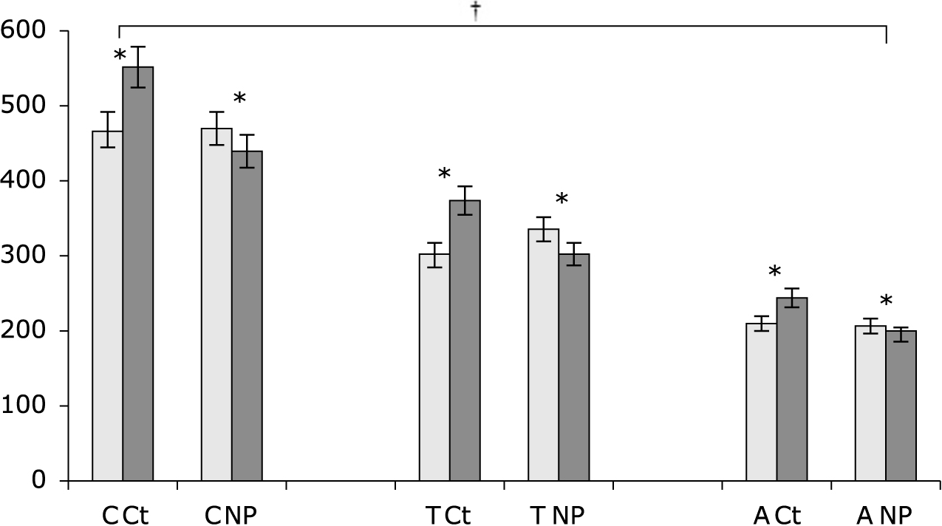
Figure 1. CoP area. CoP ellipse area in mm². Grey bar: area standing on a solid surface; black bar: area standing on foam block; C: children, T: teenagers, A: adults; NP: subject with Nociceptive Capacity of a Plantar Irritating Stimulus; Ct: control subject without Nociceptive Capacity of a Plantar Irritating Stimulus.

Table 2. Results from platform parameters values in each group and in different surfaces.
Children
Teenager
Adult
Group
Ct
NP
Ct
NP
Ct
NP
Surface
Hard
Foam
Hard
Foam
Hard
Foam
Hard
Foam
Hard
Foam
Hard
Foam
Nociceptive capacity of plantar irritating stimulus
MTP&RehabJournal 2015, 13: 298
4
CoP Area | 469.4 ± 28.1 | 552.4 ± 33.1 | 472.3 ± 28.3 | 441.5 ± 26.5 | 303.91 ± 18.2 | 375.9 ± 22.5 | 336.52 ± 20.2 | 303.62 ± 18.2 | 212.3 ± 12.7 | 245.61 ± 14.7 | 209.88 ± 12.6 | 197.76 ± 11.8
M Speed | 20.5 ± 1.23 | 21.6 ± 1.3 | 18.7 ± 1.12 | 19.3 ± 1.16 | 17.5 ± 1.05 | 18.2 ± 1.09 | 17.9 ± 1.07 | 18.4 ± 1.10 | 12.5 ± 0.75 | 13.7 ± 0.82 | 12.7 ± 0.76 | 13.4 ± 0.8
V. Speed | 14.5 ± 0.87 | 16.9 ± 1.01 | 14.9 ± 0.89 | 14.3 ± 0.91 | 11.2 ± 0.67 | 13.6 ± 0.81 | 11.5 ± 0.69 | 10.3 ± 0.69 | 8.7 ± 0.52 | 10.9 ± 0.64 | 9 ± 0.54 | 8.3 ± 0.49
Legend: Ct = control subjects without nociceptive capacity of a plantar irritating stimulus; NP = subjects with nociceptive capacity of a plantar irritating stimulus; V Speed = mean speed; V Speed = variance of speed.

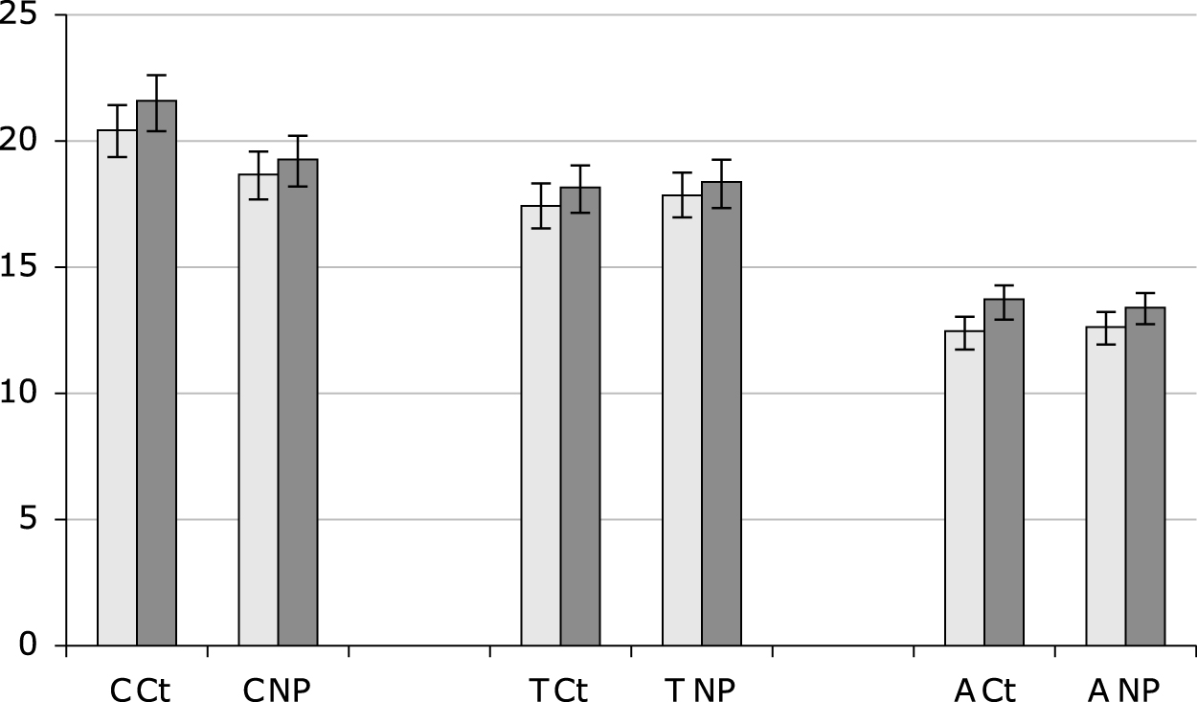
Figure 2. Mean speed of the CoP. Mean speed in mm/s. Grey bar: area standing on a solid surface; black bar: area standing on foam block; C: children, T: teenagers, A: adults. NP: subject with Nociceptive Capacity of a Plantar Irritating Stimulus; Ct: control subject without Nociceptive Capacity of a Plantar Irritating Stimulus.

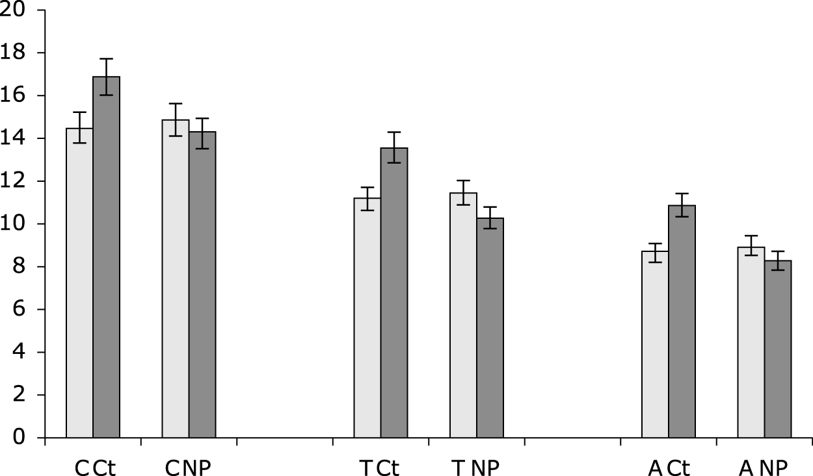
Figure 3. Variance of speed of the CoP. Variance of speed in mm/s. Grey bar: area standing on a solid surface; black bar: area standing on foam block (F); C: children, T: teenagers, A: adults. NP: subject with Nociceptive Capacity of a Plantar Irritating Stimulus; Ct: control subject without Nociceptive Capacity of a Plantar Irritating Stimulus.

A significant interaction between age (children, teenagers, adults) and CoP area (F(2,239) = 39.65, p < .001) and variance speed of CoP (F(2,239) = 42.81, p < .001) was observed as seen in figures 1 and 2 respectively, but no significantly influence was found for CoP mean speed (p = 0.28; Figure 3). Area and CoP variance speed decreased as age increased. Children presented higher values than teenagers (table 2) and these two groups combined showed higher values than adults as seen in table 2. This was observed independently of nociceptive plantar sensory information (Ct and NP) and sensory input flow induced by foam (H and F).

DISCUSSION
This study focused on plantar sensory information and posture control in subjects with and without NCPIS in different age groups. The present result suggest that the limitation of plantar tactile sensory afferent by the interposition of foam,
induce postural reaction with a variation of the oscillations in the two groups and at all ages. However the mean speed of the CoP does not differ while the area and the variation of speed they are. Postural response of the two groups is in opposition for these two parameters. Limitation of the tactile cue resulted an increase of the area and the variation speed in the Ct group so that the same condition limiting nociceptive plantar irritating stimuli cues decrease these parameters in the NP group.
When standing on a foam surface, postural control is challenged.^{(2,10)} Foam surfaces are often employed to investigate the contributions from the somatosensory systems⁽¹³⁾ and they are used in the clinical tests to determine the sensory interaction of balance.⁽²⁾ Standing on a foam surface induces modifications of somatosensory information: the foot sole surface interaction for both groups, Ct and NP, but results showed that they are divergent. Foam decreased cutaneous perception and tactile feedback for Ct subjects, but the central nervous system (CNS) is likely to still be aware for posture control. Information from the plantar mechanoreceptors is difficult for the CNS to interpret when standing on foam.⁽²⁾ In response to the quantity of sensory information, sway oscillations, and variance of speed are higher, which are necessary to maintain balance when the information from a sensory channel is blurred: more postural sways generate greater sensory input flow. The opposite is true for the NP subject. Foam reduces nociceptive flow of information to the feet and induces pressure changes under the feet.⁽⁷⁾ This situation gives new efficiency to plantar sensory information.⁽¹⁰⁾ This new plantar acuity completes the proprioceptive input flow for postural control. The plantar contribution is optimum when nociception is reduced for NP. The CNS has to weigh the sensory information from each channel in relation to its relevance to the context.^{(22,23)} As a consequence, subjects use a compensatory system and posture control is accurate (sway and variance of speed reduced) so the weight given to cutaneous information could increase and thus contribute to improving postural control.⁽²¹⁾ No effects were observed on speed when standing on foam. However, when standing on foam, it should be noted that mean speed was not disturbed, in contrast to the result obtained by Patel and collaborators.⁽²⁾ The mechanical conditions with foam are changed by the foam itself with absorb and pressure redistribution. Force distributions may influence the accuracy and properties of values recorded by the platform below the foam surface. However, another explanation for the lack of variation in speed in Ct and NP subjects could be proffered. The foam used in this study is 3 mm thick, intended simply to limit sensory input flow, i.e, only exteroceptive information, and not induce proprioceptive
modifications.
Patel et al^{(2,3)} found that standing on foam increased
biomechanical instability. However, the foam surface

dimensions – 466 mm long, 467 mm wide, 134 mm high – should be noted. In this experience, the subjects were placed at 13 centimeters high. The sensory variation induced between the hard ground and foam conditions, limited the plantar cue and disturbed the CNS sensory information with vestibular participation. The response observed was the participation of both channels and not just the plantar limitation afferent.
In addition, accurate ankle muscular proprioception may influence postural control.^{(5,10,24)} It is certainly not the same situation as in the present study where foam induced only a reduction of sensory plantar input flow. Therefore, subjects do not need to engage other sensory information (proprioception or vestibular sensory information).

Interaction between subjects of different ages
Differences observed in children, teenagers, and adults for CoP area and variance of speed could be explained by the maturation of the CNS. Postural development is not linear and children and adolescents may be in a specific phase of postural control development.^{(20,25)} Consequently, balance control is not completely optimal as in adults, but the posture control process in 10 to 12-year-olds presents less variability than in 6 to 8-year-olds.^{(20,26,27)} It was also found that children and teenagers seem to have temporal organization with sensory afferent information for the head, vision, and feet, working together, to control posture,⁽²⁵⁾ but their CNS maturation is not at the same level. This could explain the difference observed in children and adolescents.^{(6,12,28)} This temporal pattern could explain why we did not find a difference on CoP parameters. Differences between teenagers and adults could be explained by body image scheme disturbances at this age. At 13–15 years of age, body image disturbances lead subjects to possibly neglect proprioceptive information. They may rely more on other sensory systems such as vision to stabilize their body.^{(25,29,30)} In this age group, momentarily considerable changes and neglecting proprioceptive information induced greater oscillations, showing differences between teenagers
and adults.
However, the most important result regarding children, teenagers, and adults is that CoP area and variance of speed are reduced on foam (sensory condition) for the NP group, whereas these parameters were increased for the Ct group. Foam sensory variation induced changes in the temporal structure of the CoP for the Ct and NP groups. In the multisensory control of posture, sensory information from the support surface across the foot system was significant for all ages groups, mechanoreceptors and nociceptors work together at all ages.⁽³¹⁾ For the Ct group, nociceptor and mechanoreceptor afferent sensations inform the CNS on both sides.
The postural response is in function of the modulation and integration of those sensory cues. For the NP groups, NCPIS
is on the first metatarsal head and the nociceptive afferent is more important than the mechanoreceptor afferent and in excess compared of Ct group. Consequently, variation of sensitive flow (mechanoception + nociception) is intergraded by both groups, but the postural response of the two group (Ct and the NP) is, however, different. Ct group presents a postural oscillations increase in due to the limitation of sensory, physiological responses under sensory variation on foam (± equivalent to anesthesia).^{(4,10,11,24)}
This same situation of sensory reduction, reduces oscillations for the NP group. The foam will limit the nociception. Therefore the modulation of the plantar afferent will be taken into account and allow the NP to become more efficient (reduction of oscillations).
This result raises two functional consequences for the control of posture: 1) NCPIS is observed at all ages (children, teenagers, and adults); 2) as evidenced by the variations in postural sway dynamics of the NP group, NCPIS influences postural control, and neutralization of NCPIS nociception induces a new sensory organization through the CNS’s adaptation capacity during imposed standing on foam. This neutralization improves postural performance, independently of age group.

CONCLUSION
Standing on a foam surface is probably the most commonly used method to reduce sensory plantar information.⁽¹⁾ This study showed that standing on foam is an effective way to compare postural control and produces dissimilar responses. Subjects without plantar nociception responded differently than subjects with plantar nociception. A foam platform 3 mm thick decreased postural control of those without plantar nociception and in contrast facilitated the postural control of those with plantar nociception by limiting the expression of the nociceptive flow. This observation was found independent of the subject’s age and postural control maturation.

AUTHORS CONTRIBUTION
JM – article conception and data collection and analysis; LAC – article conception and writing; RBP – writing and data analysis.

COMPETING INTERESTS
The authors declare no conflicts of interest.

AUTHOR DETAILS
1 Applied Podiatry College, Poitiers, France.

REFERENCES
- Massion J. Postural control system. Curr Opin Neurobiol 1994;4:877–887.
- Patel M, Fransson PA, Johansson R, Magnusson M. Foam posturography: standing on foam is not equivalent to standing with decreased rapidly adapting mechanoreceptive sensation. Exp Brain Res 2011;208:519-527.
- Patel M, Magnusson M, Kristinsdottir E, Fransson PA. The contribution of mechanoreceptive sensation on stability and adaptation in the young and elderly. Eur J Appl Physiol 2009;105:167–173.

- Bloem BR, Allum JH, Carpenter MG, Verschuuren JJ, Honegger F. Triggering of balance corrections and compensatory strategies in a patient with total leg proprioceptive loss. Exp Brain Res 2002;142:91–107.
- Meyer PF, Oddsson LI, De Luca CJ. (a). The role of plantar cutaneous sensation in unperturbed stance. Exp Brain Res 2004;56:505–512.
- Peterka RJ. Sensorimotor integration in human postural control. J Neurophysiol 2002;88:1097–1118.
- Kavounoudias A, Roll R, Roll JP. The plantar sole is a ‘dynamometric map’ for human balance control. Neuroreport 1998;9:3247–3252.
- Forth KE, Laine CS. Neuromuscular responses to mechanical foot stimulation: the influence of loading and postural context. Aviat Space Environ Med 2008;79:844-851.
- Janin M, Dupui P. The effects of unilateral medial arch support stimulation on plantar pressure and center of pressure adjustment in young gymnasts. Neurosci Lett 2009;461:245-248.
- Meyer PF, Oddsson LI, De Luca CJ. (b). Reduced plantar sensitivity alters postural responses to lateral perturbations of balance. Exp Brain Res 2004;157:526–536.
- Stal F, Fransson PA, Magnusson M, Karlberg M. Effects of hypothermic anesthesia of the feet on vibration-induced body sway and adaptation. J Vestib Res 2003;13:39–52.
- Johansson R, Magnusson M. Human postural dynamics. Crit Rev Biomed Eng 1991;18:413–437.
- Enbom H, Magnusson M, Pyykko I. Postural compensation in children with congenital or early acquired bilateral vestibular loss. Ann Otol Rhinol Laryngol 2001;100:472–478.
- Perry S, McIllroy W, Maki B. The role of plantar cutaneous mechanoreceptors in the control of compensatory stepping reactions evoked by unpredictable, multi-directional perturbation. Brain Res 2000;877:401–406.
- Zaino C.A, McCoy S.W. Reliability and comparison of electromyographic and kinetic measurements during a standing reach task in children with and without cerebral palsy. Gait Posture 2008;27:128-137.
- Lewis GN, Rice DA, Jourdain K, McNair PJ. Influence os stimulation location and posture on the reliability and comfort of the nociceptive flexion reflex. Pain Res Manag 2012;17:110-114.
- Morioka S, Fujita H, Hiyamizu M, Maeoka H, Matsuo A. Effects of Plantar perception training on standing posture balance in the old and the very old living in nursing facilities: a randomized controlled trial. Clin Rehabil 2011;25:1011-1120.
- Janin M. Is the distribution of the Nociceptive Capacity of Plantar Irritating Stimulus different in dyslexic children in the non-dyslexiques? Clinical Neurophysiology 2012;42:397-398.
- Janin M. Repartition and evaluation of the Nociceptive Capacity of Plantar Irritating Stimulus for the athlete. La revue du podologue, Elsevier Masson, France. 2011;42:10-14.
- Sobera M, Siedlecka B, Syczewska M. Posture control development in children aged 2-7 years old, based on the changes of repeatability of the stability indices. Neurosci Lett 2011;491:13-17.
- Thedon T, Mandrick K, Foissac M, Mottet D, Perrey S. Degraded postural performance after muscle fatigue can be compensated by skim stimulation. Gait Posture 2011;33:686-689.
- Van Beers RJBP, Wolpert DM. Role of uncertainty in sensorimotor control. Phil Trans R Soc Lond [BR] 2002;357:1137–1145.
- Fransson PA, Gomez S, Patel M, Johansson L. Changes in multi-segmented body movements and EMG activity while standing on firm and foam support surfaces. Eur J Appl Physiol 2007;101:81–89.
- Assaiante C, Mallau S, Viel S, Jover M, Schmitz C. Development of postural control in healthy children: a functional approach. Neural Plasticity 2005;12:109-118.
- Hinman M.R. Validity and reliability of measures obtained from the balance performance monitor during quiet standing. Physiotherapy 1997;83:579-581.
- Viel S, Vaugoyeau M, Assaiante C. Adolescence: a transient period of proprioceptive neglect in sensory integration of postural control. Motor Control 2009;13:25-42.
- Bernard-Demanze L, Dumitrescu M, Jimeno P, Borel L, Lacour M. Age- relatade changes on posture control are differentially affected by postural and cognitive task complexity. Curr Aging Sci 2009;2:139-149.
- Assaiante C, Chabeauti PY, Sveistrup H, Vaugoyeau M. Updating process of internal model of action as assessed from motor and postural strategies in young adults. Hum Mov Sci 2011;3:227-237.
- Wu G, Chiang JH. The significance of somatosensory stimulations to the human foot in the control of postural reflexes. Exp Brain Res 1997;114:163–169.
- Clark S, Riley MA. Multisensory information for postural control: sway- referencing gain shapes center of pressure variability and temporal dynamics. Exp Brain Res 2007;176:299-310.
- Kennedy PM, Inglis JT. Distribution and behavior of glabrous cutaneous receptors in the human foot sole. J Physiol 2002;538:995-1002.

